**Improving health for**

**people with a learning disability**

**28th November 2017, Strawberry Lodge, Carshalton**

**Background**

|  |  |
| --- | --- |
| https://cdn.shopify.com/s/files/1/0606/1553/products/Group-33_grande.png?v=1417855028 | The conference was all about health services for people with a learning disability. |
| \\SM-DC01\RedirectedFolders$\David\Downloads\P1040550.JPG | Around 100 people attended the conference. |
|  | Lots of people helped to organise the conference. |
| [Sutton Parents Forum logo](http://suttonparentsforum.org.uk/) | The conference was paid for by Sutton Parents Forum and Sutton Mencap. |
| Mavis Peart OBE | The conference was chaired by Mavis Peart, Chair of Sutton Mencap. |

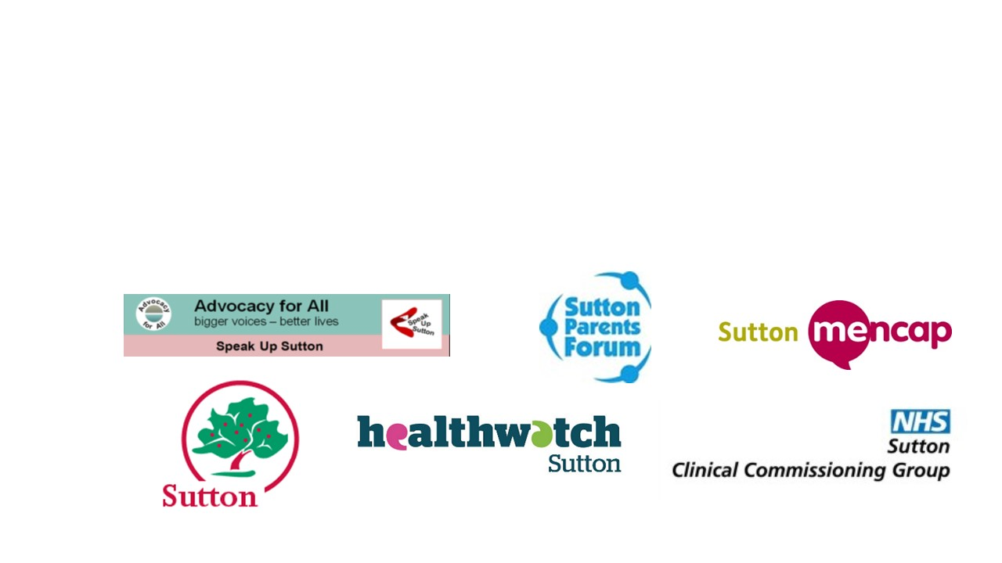

**Health passports, health action plans and annual health checks**

|  |  |
| --- | --- |
|  | Jane Watts and Choonwha Jung from the Sutton Clinical Health team gave a presentation. |
|  | Jane and Choonwha talked about health passports. |
|  | Someone with a learning disability can use a health passport to tell staff about themselves. |
|  | You can get a blank copy of the health passport at [www.easyhealth.org.uk/listing/hospital-passports-(leaflets)](http://www.easyhealth.org.uk/listing/hospital-passports-(leaflets)). |
|  | If you are in hospital, you can also ask for help from the Learning Disabilities Liaison Nurse. |
|  | You can also get an annual health check at your GP surgery. |
|  | You can find out more about annual health checks at [www.nhs.uk/Livewell/Childrenwithalearningdisability/Pages/AnnualHealthChecks.aspx](http://www.nhs.uk/Livewell/Childrenwithalearningdisability/Pages/AnnualHealthChecks.aspx) |

**Eye care services**

|  |  |
| --- | --- |
| C:\Users\david.SUTTONMENCAP\AppData\Local\Microsoft\Windows\Temporary Internet Files\Content.IE5\FBH0EBFZ\P1040553.JPG | Subodh Rusdharry, Health Commissioning Manager gave a presentation. |
|  | Subodh talked about eye tests, which can help people have healthy eyes and see well. |
| https://cdn.shopify.com/s/files/1/0606/1553/products/Optician_Eye_Test2_large.png?v=1417849409 | People with a learning disability can use a special eye test service which gives people more time. The service is provided by an optician. |
|  | Before having an eye test, you should fill in a form called ‘telling the optician about me’. You can get this form at [www.seeability.org/preparing-for-an-eye-test](http://www.seeability.org/preparing-for-an-eye-test)) |
|  | You should also take a feedback form with you which the optician will fill in. You can get this form at [www.seeability.org/after-the-eye-test](http://www.seeability.org/after-the-eye-test) |

**Free flu jabs**

|  |  |
| --- | --- |
|  | Debbie Calver, Infection Prevention and Control Specialist Nurse, Public Health talked about flu jabs. |
| https://cdn.shopify.com/s/files/1/0606/1553/products/Flu-Vaccine_large.png?v=1511018101 | Debbie told people how a flu jab can stop people from catching flu. |
| https://cdn.shopify.com/s/files/1/0606/1553/products/Group-19_large.png?v=1417854961 | People with a learning disability can get a free flu jab. So can their parents and carers and their support workers. |
|  | Debbie showed a film about flu jabs which has been made for people with a learning disability. You can watch it at [www.youtube.com/watch?v=TYgH181Xijs](http://www.youtube.com/watch?v=TYgH181Xijs). |
|  | There is also an easy-read document about the flu jab at [www.gov.uk/government/publications/flu-leaflet-for-people-with-learning-disability](http://www.gov.uk/government/publications/flu-leaflet-for-people-with-learning-disability). |

**Improving oral health**

|  |  |
| --- | --- |
| [King's College Hospital - NHS Foundation Trust](https://www.kch.nhs.uk/) | Dr Fereshteh Taleifaz, Senior Dental Officer, Kings College Hospital gave a presentation. |
| https://cdn.shopify.com/s/files/1/0606/1553/products/Dentist-Checkup-5_large.jpg?v=1505377708 | Fereshteh talked about the Community Special Care Dentistry service. |
| [https://cdn.shopify.com/s/files/1/0606/1553/products/Teeth-1_compact.png?v=1417849528](https://www.photosymbols.com/products/teeth-1) | This service can help people with a learning disability look after their teeth and gums. |
| https://cdn.shopify.com/s/files/1/0606/1553/products/Dentist-Appointment-Show_large.png?v=1417848851 | You can go to a dentist or if needed you can go to hospital, or the dentist can come to your home. |

**What people say about using health services**

|  |  |
| --- | --- |
|  | Members of Speak up Sutton gave a presentation. |
| https://cdn.shopify.com/s/files/1/0606/1553/products/Waiting-Room-2_large.png?v=1511015597 | They talked about how health services could be made better for people with a learning disability. |
| [https://cdn.shopify.com/s/files/1/0606/1553/products/Place_Waiting_Room_compact.png?v=1417855832](https://www.photosymbols.com/products/place-waiting-room) | They talked about having more time for appointments and a quiet place to talk to someone. |
| [https://cdn.shopify.com/s/files/1/0606/1553/products/Hospital-1_compact.png?v=1418508188](https://www.photosymbols.com/products/hospital-1) | Mark Rawlings also talked about his recent visit to hospital. |
| https://cdn.shopify.com/s/files/1/0606/1553/products/Group-33_large.png?v=1417855028 | Mark had spent a lot of time telling lots of different people about himself. |
| https://cdn.shopify.com/s/files/1/0606/1553/products/Health-Passport_large.png?v=1511173543 | Mark though a hospital passport was a good idea. |

**Question time**

|  |  |
| --- | --- |
|  | People asked questions about health services to a panel of experts. |
|  | Barbara McIntosh, Vice Chair of Healthwatch Sutton was a panel member. |
|  | George Platts, Head of Mental Health, Transitions, Community and Clinical Health, London Borough of Sutton was a panel member. |
|  | Clare Wilson, Deputy Managing Director, Sutton Clinical Commissioning Group was a panel member. |
| https://cdn.shopify.com/s/files/1/0606/1553/products/Information_Sign_large.png?v=1417850564 | People talked about the need for more information about health services. |
| https://cdn.shopify.com/s/files/1/0606/1553/products/Fed_Up-2_large.png?v=1417852597 | People talked about mental health services for people with a learning disability |
| https://cdn.shopify.com/s/files/1/0606/1553/products/Place_Training_Room_large.png?v=1417855824 | People also talked about training for health staff on how to help people with a learning disability. |

**Where you can find out more**

London Borough of Sutton Clinical Health Team

[www.sutton.gov.uk/directory_record/87506/sutton_clinical_health_team_for_people_with_learning_disabilities](http://www.sutton.gov.uk/directory_record/87506/sutton_clinical_health_team_for_people_with_learning_disabilities)

Kings College Hospital Community Special Care Dentistry

[www.kch.nhs.uk/service/a-z/community-special-care-dentistry](http://www.kch.nhs.uk/service/a-z/community-special-care-dentistry)

Mencap health campaign

[www.mencap.org.uk/advice-and-support/health](http://www.mencap.org.uk/advice-and-support/health)

Sutton Parents Forum

[www.suttonparentsforum.org.uk](http://www.suttonparentsforum.org.uk)

Speak Up Sutton

[www.advocacyforall.org.uk/self.php#sutton-su](http://www.advocacyforall.org.uk/self.php#sutton-su)

Healthwatch Sutton

[www.healthwatchsutton.org.uk/](http://www.healthwatchsutton.org.uk/)

Sutton Mencap

[www.suttonmencap.org.uk](http://www.suttonmencap.org.uk)

[https://cdn.shopify.com/s/files/1/0606/1553/t/7/assets/logo-signed-in.png?12816656371138970622](https://www.photosymbols.com/collections/all)

This report has been produced using

