

**Speak Up Sutton**

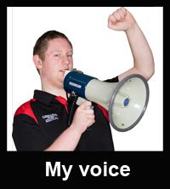



**Talk about your support**

* time for **service users, support workers and managers** totalk about **how to make things better.**
* **‘let’s make support work for everyone’ report**
* **taking action together**

**On: Wednesday 16 November 2016**

**Time: 1pm til 3pm**

**at: Trinity Centre**

Holy Trinity Church

Maldon Road

Wallington

SM6 8BL

**Contact:** 020 8669 0500

[**rachel.coates@advocacyforall.org.uk**](mailto:rachel.coates@advocacyforall.org.uk)

supported by

**Speak up Sutton**, **Sutton Mencap** and **Healthwatch Sutton**







[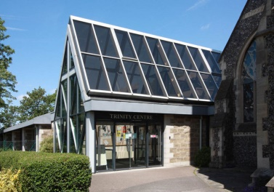](http://www.google.com/url?sa=i&rct=j&q=&esrc=s&source=images&cd=&cad=rja&uact=8&ved=0CAcQjRxqFQoTCM6h_I2c-8cCFcm6FAodYdgGuA&url=http://www.geograph.org.uk/photo/2426401&psig=AFQjCNElPVTkYCw1LkAghUIZg160FxfL0w&ust=1442481343590860)





Image result for healthwatch sutton logo