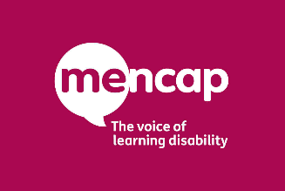

**Sports Inclusion Day**

17th June 2019, 10.00am to 2.00pm

David Weir Leisure Centre

The Here We Are campaign is in celebration of Mencap being named as the official charity partner for the 2020 London Marathon. To kick off Learning Disability Week 2019, we are putting together a packed day of sports for people with a learning disability, families and carers and the wider community.

There’ll be lots to try including cricket, dance, cycling, table tennis, gym, circuit training boccia and football. Make sure you bring some suitable clothes and footwear and a bottle of water (there is also a café on site).

We will also have the Community Health Team attending to provide useful health advice. There will also be a chance to find out how you can get involved in local sports clubs and activities and to have your say on sporting activities in Sutton.

Sports Inclusion Day is all about promoting and celebrating the participation of people with a learning disability in sports alongside the rest of the community. You don’t have to have a learning disability to attend. Everyone is welcome.

Please let us know if you plan to attend by contacting Sutton Mencap on 020 8647 8600. If you are coming as a group please make sure you complete the attached group booking form.





