

**Speak Up Sutton**



Come and talk about **keeping safe and asking for help**

at our **open meeting!**

**On: Wednesday 1 March**

**Time: 12.30 til 2.30pm**

**at: Trinity Centre**

Holy Trinity Church

Maldon Road

Wallington

SM6 8BL

**Contact:** 020 8669 0500

**[rachel.coates@advocacyforall.org.uk](mailto:rachel.coates@advocacyforall.org.uk)**

**funmi.ogunjinmi@advocacyforall.org.uk**









[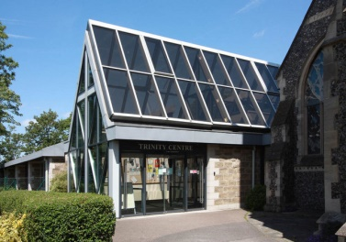](http://www.google.com/url?sa=i&rct=j&q=&esrc=s&source=images&cd=&cad=rja&uact=8&ved=0CAcQjRxqFQoTCM6h_I2c-8cCFcm6FAodYdgGuA&url=http://www.geograph.org.uk/photo/2426401&psig=AFQjCNElPVTkYCw1LkAghUIZg160FxfL0w&ust=1442481343590860)





