HAPPY NEW YEAR!

Sutton Parents Forum January 2017 Café
Welfare Benefits Workshop
Steve Triner of Citizens Advice Sutton and Julian Clift, Welfare Reform Outreach Officer for the London Borough of Sutton, will provide an overview of the options for welfare benefit entitlements including Universal Credit as young people with disabilities transition to claiming welfare benefits in their own right.
The session will include issues such as when young people can claim benefits and the impacts on any benefits the parents may be receiving.
In the session, there will be a presentation, group discussion and the opportunity to access confidential one-to-one advice.
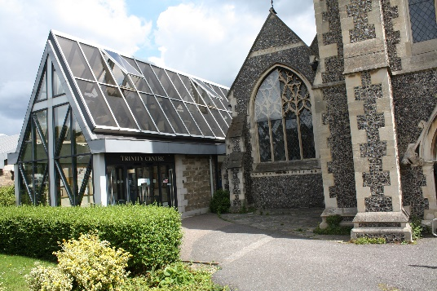
Where? Holy Trinity Church,
Maldon Road,
Wallington,
SM6 8BL
When? 26th January 2017
10.15am – 1.30pm
Refreshments will be served from 10.00am and the session will start at 10.15am. A buffet lunch will be provided from 12.30pm to give everyone the opportunity to meet and chat with other parent/carers as well as the professionals.

Contact us:
suttonparentsforum@outlook.com
www.facebook.com/Sutton-Parents-Forum
www.suttonparentsforum.org.uk
020 3701 2175

