This is my

**Healthcare Passport**

Please place photo of me here

My name is:

NHS number: DOB:

If I attend a healthcare appointment or go into hospital, this healthcare passport needs to go with me.

It needs to hang at the end of my bed and a copy should also be put in my notes.

**This passport belongs to me. Please return it when I am discharged**.

Please assume that I have capacity to make decisions unless otherwise specified. This passport is a guide to help you learn more about me and my preferences.

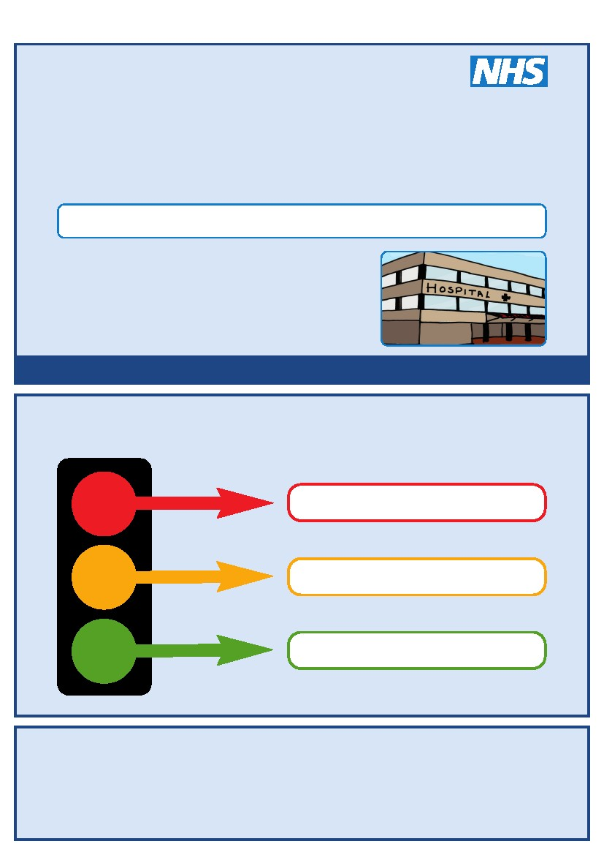

**Allergies:**

**#**



For people with learning disabilities attending healthcare appointments

Things you must know about me

Things that are important to me

My likes and dislikes

Completed by: Date:

**Things you must know about me**

**My address:**

**Tel No:**

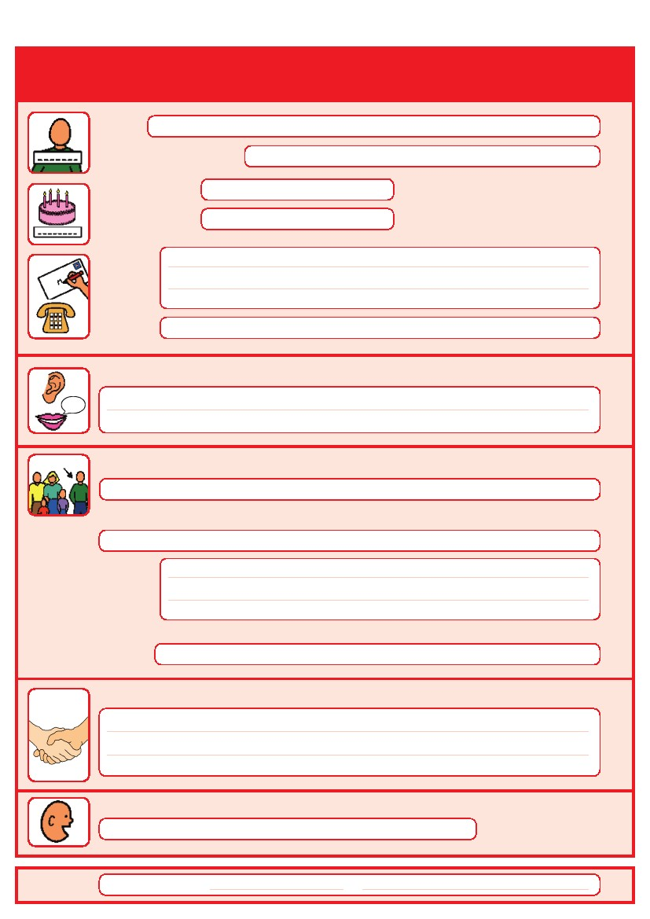

**Family member:**

**Tel No:**



**How I communicate / what languages I speak:**

**Simple sentences**

**Makaton**

**Picture cards/chart**

**Non-verbal**

**Gestures**

**Tactile prompting**

**Communication aid (document what aid in other)**

**Other:**



**GP**

**Details:**

**Key professionals in my care:**

Click here to type

Click here to type

Click here to type

Click here to type

Click here to type

Click here to type

Click here to type

**Things you must know about me**

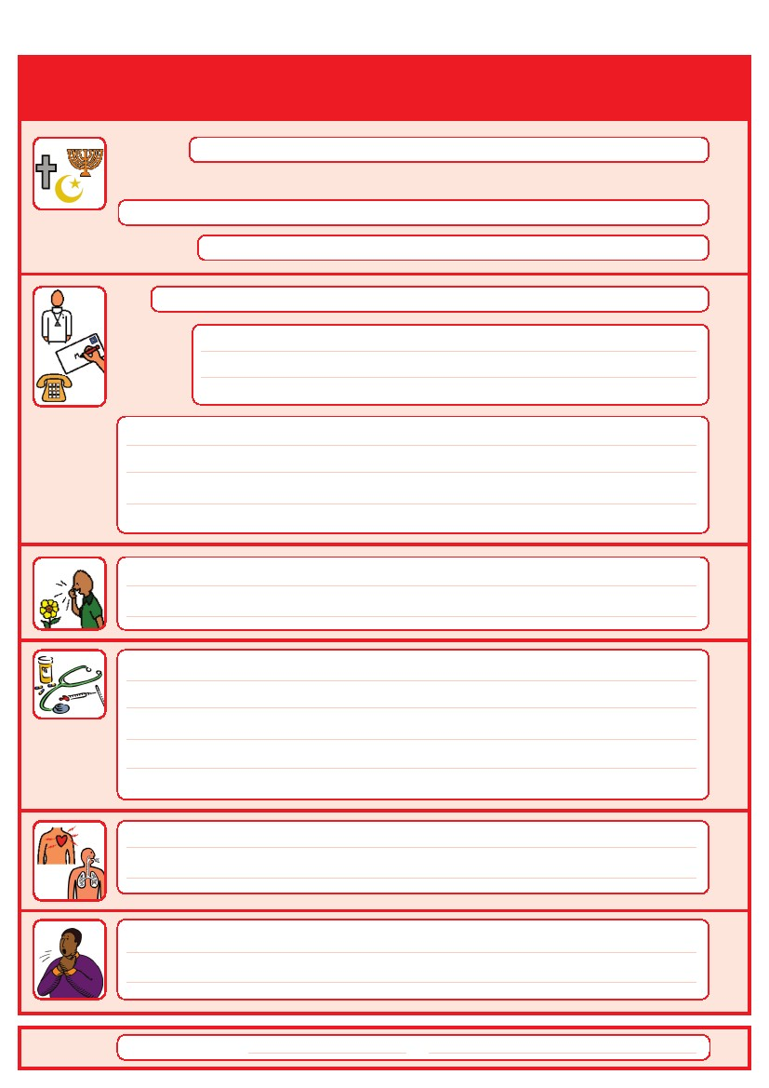

**Religion:**

**Religious / spiritual needs:**

**Ethnicity:**



**Does my food need to be cut up or liquidised? Do I use dentures to eat?**

**If there is a risk I may choke please give details of my management plan,   
seating and posture:**



**Medical interventions: anything healthcare workers need to know such as how to take your blood and observations**

**Any reasonable adjustments healthcare professionals can make e.g. someone to be with you all the time**

**Anything that scares you in the hospital**

Click here to type

Click here to type

Click here to type

Click here to type

Click here to type

Click here to type

Click here to type

Click here to type

**Things you must know about me**

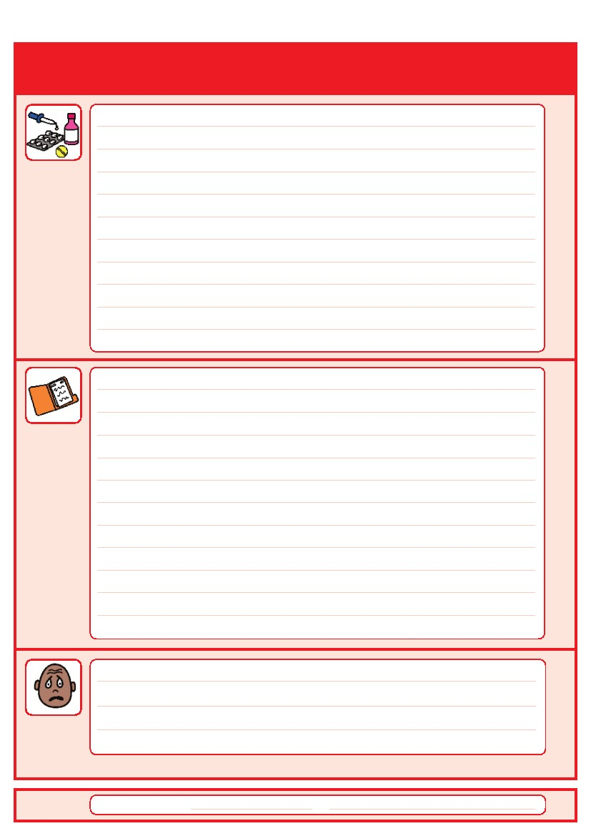

**Current medications:**

**Medical History**

**& treatment plan:**



**How do I show I’m in pain:**

**How to support me if I’m in pain:**

**What to do if I am anxious:**

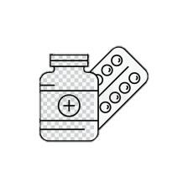

**How I take medication:**

**Whole tablets:**

**Crushed:**

**Injections:**

**Liquid:**

**Other:**

Click here to type

Click here to type

Click here to type

Click here to type

Click here to type

Click here to type

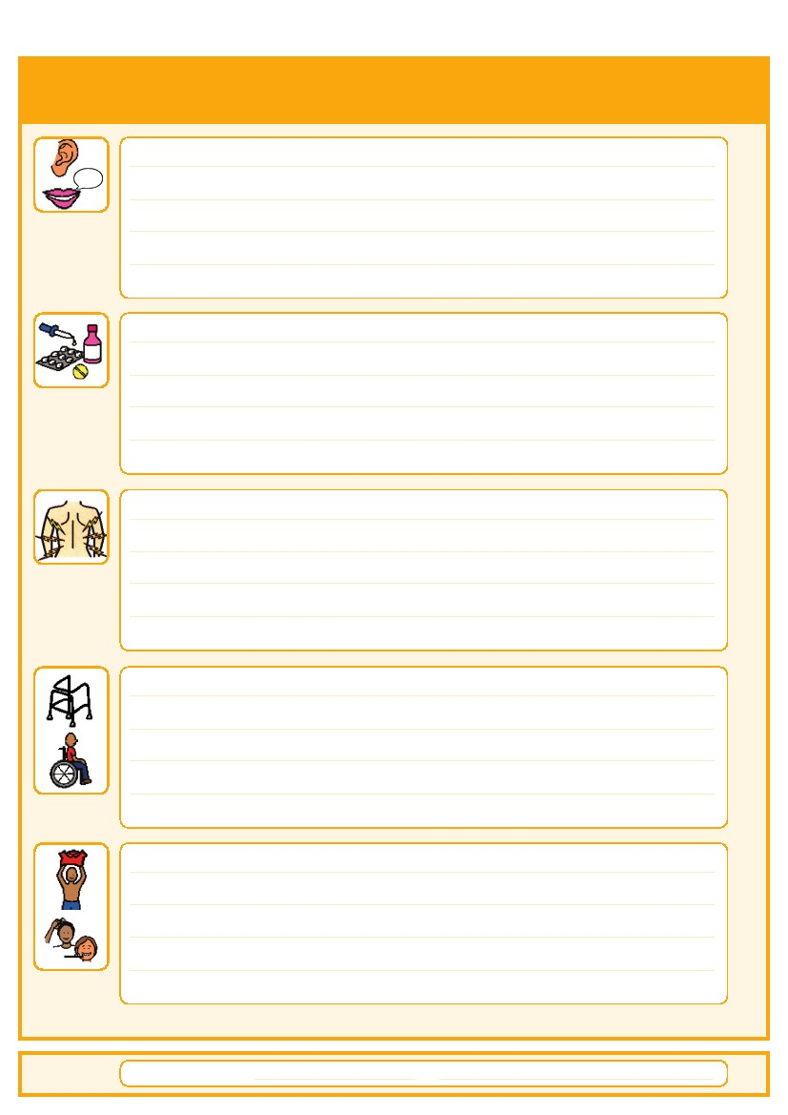

**Things that is important to me**

**How to communicate   
with me:**

**How I mobilise   
& move around:**

**Personal care:**

**Any problems with vision or hearing:**

**How I eat:**

**How I drink:**

**How I keep safe:**

**How I use the toilet:**

**Sleeping:**

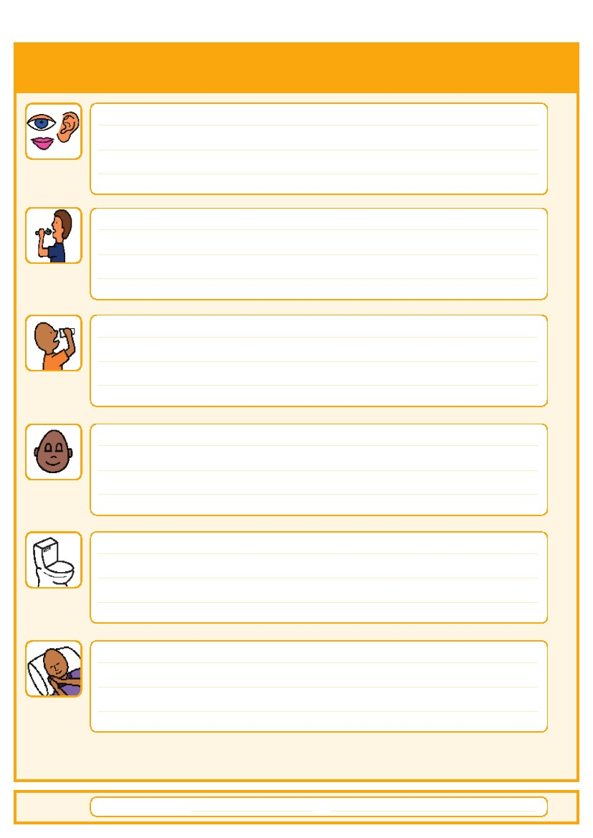

*Do you need help washing and dressing?*

*Cut up, pureed, need help to feed you?*

*Small amounts? Thickened fluids?*

*Bed rails, support with challenging behaviour?*



Click here to type

Click here to type

Click here to type

Click here to type

Click here to type

Click here to type

Click here to type

Click here to type

Click here to type

Click here to type

Click here to type

**My likes**

**My dislikes**



**What makes me happy?**

**Things I like to do such as watching TV, reading, music, routines etc.**

**What makes me unhappy?**

**Things I dislike such as shouting, physical touch, any food I dislike etc.**

Click here to type

**Notes**

***Anything else you feel professionals should be aware of:***

Click here to type

Based on a previous ‘Healthcare Passport’ this version is designed to be used for people within a variety of settings.

This content was revised and updated by the Learning Disability Service at Epsom & St Helier University Hospitals NHS Trust, Sutton Learning Disability Health Facilitator and Service Improvement Programme Manager and the Clinical Health Team for Adults with Learning Disabilities, Sutton Health and Care.

This content was adapted and designed by Hazel Barnes and Dara Shortall as part of the Learning Disability service at Epsom & St Helier University Hospitals NHS Trust.

**Useful Contacts**