Service user Involvement Policy

Aims
The aims of this policy are:
- To support Sutton Mencap to deliver its key strategic aims of improving life skills, promoting independence and enabling choice and control.
- To ensure that the views of service users are valued and listened to in all aspects of the organisation.
- To ensure the services offered reflect the needs and wishes of service users.

Introduction
Sutton Mencap believes that all people with a learning disability should be able to lead fulfilling lives and achieve their aspirations and potential. We recognise that central to this belief is ensuring that the voice of service users is at the heart of the organisation, shaping all aspects of our services and activities.

This helps us to ensure that our activities remain relevant to service users. It also encourages service users to recognise that their voice matters. People with a learning disability have a right to speak up and be listened to in all aspects of their life, both within and outside of Sutton Mencap.

We recognise the barriers that exist for service users to participate in Sutton Mencap and are committed to overcoming those barriers wherever possible. This commitment includes:
- Making sure that relevant information is provided in a range of formats, including producing easy read documents.
- Meeting with service users to provide an opportunity for them to feedback on key issues.
- Recognising the range of communication methods which can be used by service users to express their views.
- Making the best use of new technology to support communication.
- Allowing service users the time they need to respond.
- Working in partnership with parents and carers to help gain a better understanding of the needs and wishes of service users.

Scope
All trustees, staff and volunteers should comply with this policy. The policy covers all aspects of the organisations work, including governance and management, staff recruitment, service design and delivery.

Governance and management
We will seek to ensure the voice of service users is heard at all levels of the organisation. We will:
- Encourage representation from service users and carers on our board of trustees.
- Establish steering groups to oversee delivery of specific projects.
- Encourage service users to become voting members of Sutton Mencap.
- Consult on key developments within Sutton Mencap, such as the development of a new strategic plan, or significant service development.

We will also carry out an annual consultation across all our services. The results will be reported to trustees and will be used to help develop and improve our services. We will provide feedback to service users and carers on what we learned and what how responded.

Staff recruitment
We will involve service users in the recruitment of senior managers within the organisation. We will also involve service users in the recruitment process for sessional staff on our adult services. The involvement of service users can be through direct representation on the interview panel, or participation in a separate service user panel.

Service delivery
We recognise the importance of ensuring service users exercise choice and control whilst using our services. We will therefore ensure that service users are able to choose the activities that take place on our services.

We want our staff to demonstrate excellent communication with service users. We will provide training and support to staff to help them communicate appropriately with service users and to understand the ways in which service users communicate with us. We will maintain and update our service users’ records so that our understanding of the specific needs of each service user is shared across the support staff team.

We recognise the opportunities that new technology can provide to support communication. We will seek to maximise the use we make of such technology.

We will encourage regular contact with parents and carers of people who use our services, especially children and young people. We recognise that parents and carers have a vital role in helping us understand the needs and wishes of service users.

We recognise that our support staff spend a great deal of time with service users and provide us with a valuable method for understanding the needs, wishes and concerns of service users. We will encourage staff to speak up in relation to issues raised with them on service.

Responsibilities

Trustees
- To approve and review the policy on a regular basis
- To take reasonable steps to satisfy themselves that the policy is being implemented.

Senior staff
- To act in accordance with the policy.
- To communicate the policy to other staff and volunteers and to ensure it is being implemented correctly.
- To monitor performance of the policy and report to trustees

All Staff and volunteers
- To act in accordance with the policy

Related policies and procedures
- Complaints procedure
- Quality assurance policy
- Strategic plan

Signed on behalf of the Trustee Board of Sutton Mencap

Chairman: 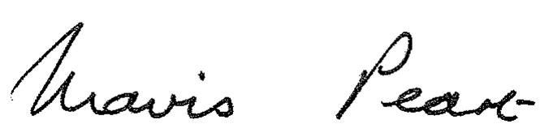 Date: December 2017
Mavis Peart

