Sick Procedure for Individual during Service

In the event of an Individual becoming sick or involved in an accident whilst in our care, this procedure will be followed:

1. Support Staff will alert the Co-ordinator and/ or first aider to support an assessment of the individual’s condition. Appropriate care/ first aid and attention will be given to support the person.

2. If the person requires rest/ isolation due to feeling unwell a bed can be made up on the sofa in either the children’s lounge or in the adult lounge if this is vacant. If children’s lounge is being used the other people will be offered activities in other rooms in the children’s area. The person will be supported at all times.

3. Parents/ carers or emergency contact will be informed and asked to make arrangements to collect the person as soon as possible.

4. Meanwhile, if the individual’s health deteriorates while waiting for the parent/ carer basic first aid will be administered and an ambulance will be called. Staff member will accompany and remain with person until parent/ carer arrives.

Signed on behalf of the Executive Committee of Sutton Mencap
Chairman: 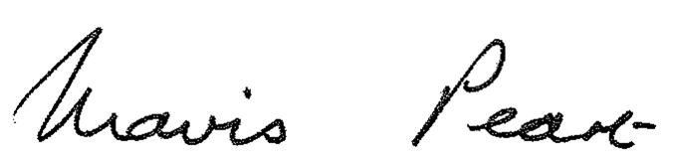 Date: January 2015
Mavis Peart

Reviews: 2018
2020

